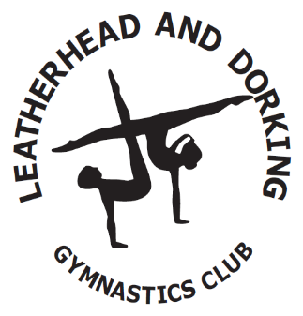

CODE OF CONDUCT FOR SQUAD GYMNASTS’S PARENTS & GUARDIANS

- Parents are required to accompany their children to and from the gymnasium; coaches will ensure safe dismissal of gymnasts to their parents. We would appreciate your child being collected promptly following their session, if you’re running late please contact the relevant coach failure to do so within 45 minutes of the session ending will result in social services being called.

- Parents are not allowed to be in the gymnasium during training sessions, unless invited by a coach, briefly to collect young children or at organised events (competitions, fundraising etc.) Conversations with coaches should be kept until after the session is completed. Pushchairs are not to enter the gym due to being a fire hazard, they should be left outside under the canopy.

- Encourage your child to learn the rules and participate within them.

- Discourage challenging / arguing with officials.

- Accept officials’ judgements.

- Help your child to recognise good performance, not just results.

- Set a good example by recognising good sportsmanship and applauding the good performances of all.

- Never force your child to take part in sport.

- Parents should ensure that all gymnasts are wearing appropriate clothing for their discipline, jewellery is prohibited and long hair should be tied back. All male gymnasts are required to have their hair such that their forehead and back of their neck is fully visible at all times. Fingernails should be kept to an acceptable length as not to scratch or harm the coach or other participants during training.

- Please ensure that your child has plenty to drink.

- Keep the club informed if your child is ill or unable to attend sessions.

- Parents should ensure that the gymnasts keep to the agreed timings for training and competitions and inform their coach if they are going to be late.
- Punctuality in training is considered an essential part of a gymnast’s practice and responsibility. Gymnasts should be punctual in the following instances:
- The start of morning, afternoon and evening training sessions.
- The start of training after a given break.
- Any activity concerning competition, training camps, trips etc.
- Any meetings required to attend.

- It is the parents/guardians responsibility to text/call/email the coach prior to the class to explain the reason for the gymnast being late or needing to finish early. Should this be a frequent occurrence, your child may be offered an alternative class with hours that suit your needs better.

- As a Leatherhead & Dorking Gymnastics Club member, gymnasts should not attend any training session at another club unless their coach is present.

- Endeavour to establish good communications with the club, coaches and officials for the benefit of all.

- Share any concerns or complaints about any aspect of the club through the appropriate Director.

- Use correct and proper language at all times.

- Never punish or belittle a child for poor performance or making mistakes.

- Always collect your child promptly at the end of a session.

- Support your child’s involvement and help them to enjoy their sport.

- Do not give coaches personal mobile phone numbers to your child/gymnast. Contact for information etc. must always be done via the parent/guardian.

- Do not park in the “Drop Zone” this is for dropping gymnasts off only. Leaving your car unattended in the drop zone is not allowed and whilst you are bringing your child in means that other parents cannot be dropped off in a safe area putting children at risk.

Should the Club feel that this code of conduct is not being adhered to then we will initially arrange a meeting to discuss the matter. We would hope to resolve amicably depending on the severity of the situation.

Gymnast’s Name:

……………………………………………………..

........................................................... .......................................................... ................................
Squad Gymnast Parent / Guardian Sign Date

